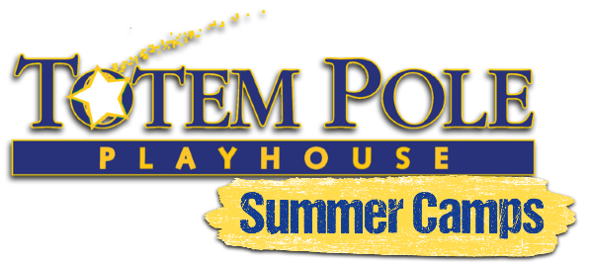

Revised February 2022
PLEASE READ CAREFULLY. THIS DOCUMENT IS LEGALLY BINDING. BY SIGNING THIS AGREEMENT, YOU ARE RELEASING TOTEM POLE PLAYHOUSE FROM ALL LIABILITY FROM ILLNESS, INJURY, LOSS OR DAMAGE RELATED TO ATTENDING A TOTEM POLE PLAYHOUSE SUMMER CAMP.
We are committed to following state and local guidelines and reserve the right to update this waiver at any time. Any information that your family provides in relation to health and/or emergency contacts is always kept confidential.
COVID-19 RELATED POLICY AGREEMENTS AS OF 2.14.22:
• Families must commit to their children’s ability to comply with all social distancing and health protocols as established by Totem Pole Playhouse camps before sending them. We reserve the right to suspend a camper or cancel a camp group if social distancing or proper hygiene (including mask wearing (if mandatory), handwashing, coughing, nose blowing, etc.) is not practiced.
• Screenings of campers may be required every day upon arrival to camp.
• Campers with underlying health conditions must consult with their doctor about their decision to attend camp.
• Campers may not attend camp if they, anyone in their household, or anyone with whom they have been in close contact exhibits any symptoms of COVID-19 or tests positive within 14 days of the start of camp.
• Families are required to prescreen their camper’s health status and be conscious of the safety of their family, social, and public activities in the 14 days leading up to camp and during camp itself.
• While we will follow all government and CDC requirements to the best of our ability, we are not able to guarantee the health of your child or family.
First Aid and Emergency Authorization: I acknowledge that camp activities come with a risk of injury. I further understand that the staff is trained in basic emergency response. I hereby give permission to certified staff to provide routine first aid and CPR, to seek emergency medical treatment, and/or to arrange related transportation for my child, as necessary. I agree to hold Totem Pole Playhouse harmless for any loss, damage or injury to person or property that may arise out of my child’s participation in this program.
Non-COVID Related Behavior Policy: I understand that Totem Pole Playhouse strives to create a safe, fun, and supportive environment. Campers are introduced to the basic rules of behavior at camp on the first day of the session stressing the importance of treating campers and staff with respect. I understand that if a situation should arise in which my child is unable to follow the rules, acts in a manner that makes it impossible for the group to function normally, or displays behavior that jeopardizes the health and safety of an individual or the camp as a whole, we reserve the right to remove your child from the session and will not allow a refund, partial or otherwise.
Photo/Video Release: I hereby give permission to Totem Pole Playhouse to use my or my child's photographic likeness and or video recordings in any editorial and/or promotional material produced and/or published by Totem Pole Playhouse in any form of printed or electronic media. I agree to contact Totem Pole Playhouse in writing prior to the camp season if I choose not to allow my child’s photo, video recordings, name or likeness to be used. I hereby waive any right to inspect or approve the finished product in which my or my child's photographic or video recording likeness appears, or any copy that may be used in connection with it, now or in the future. I waive any right to royalties or other compensation arising from, or related to, the use of any photographic or video recording likeness.
YOU WILL BE ASK TO SIGN THIS WAIVER & RELEASE UPON REGISTRATION. BY SIGNING THIS WAIVER & RELEASE FORM, YOU ARE RELEASING, WAIVING, DISCHARGING, AND CONVENANTING NOT TO SUE THE TOTEM POLE PLAYHOUSE FOR ANY ILLNESS, INJURY, LOSS OR DAMAGE RELATED TO ATTENDING A TOTEM POLE PLAYHOUSE SUMMER CAMP.
Camper’s Names ________________________________________________________________________________
___________________________ ____________________________ __________________
Parent/Guardian Name Parent/Guardian Signature Date

